诚邀参加第五届电子科技大学国际青年学者论坛
Warmly Welcome to the Fifth UESTC International Forum for Young Scholars
一、介绍
- Introduction
电子科技大学国际青年学者论坛（“成电论坛”），旨在将海内外优秀青年学者汇聚在“天府之国”——成都，促进海内外青年学者之间的交流，增强不同研究领域之间的合作。截至目前，成电论坛已成功举办四届，共邀请来自美国、英国、德国、瑞士、澳大利亚、新加坡等20余个国家和地区的400余位青年学者来校交流访问。国际青年学者论坛网上平台常年开放，欢迎海内外学者访问！
UESTC International Forum for Young Scholars (UESTC Forum) aims at gathering outstanding scholars all over the world to Chengdu—the Land of Abundance, and enhancing the interaction and cooperation among prominent young scholars with interdisciplinary backgrounds. So far, we have held consecutively four forums. More than 400 young scholars in total from over 20 countries and regionswere invited, such as the United States, Britain, Germany, Switzerland, Australia, Singapore and so on.The forum websiteis available all the year round.
时间安排/Forum Agenda
2017年11月22日 | 报到
2017年11月23日 | 主题论坛：特邀嘉宾做报告
2017年11月24日 | 分论坛：分领域交流
Nov. 22, 2017 | Registration
Nov. 23, 2017 | Opening Ceremony and Invited Speech
Nov. 24, 2017 | Sub-Forums in different fields
二、申请条件（以下两者满足其一）
- Basic Qualifications (Meet one of the following two)
1）青年千人、青年拔尖人才、青年长江学者、优青、百篇优博获得者或全球高被引科学家（汤森路透发布）
- Selected ones of the Recruitment Program for Young Professional, National Program for Support of Top-notch Young Professionals, Young Program of Yangtze River Scholars, Excellent Young Scientists Fund or Top 100 Reward of the National Excellent Doctoral Dissertation, or Highly Cited Researchers (released by Thomson Reuters).
2）年龄在40岁以下；在海外知名高校、科研机构或知名企业研发机构有正式教学或科研职位，取得博士学位后在海外连续工作36个月以上（业绩条件特别突出的海外博士可申请破格）的优秀青年学者。
- Outstanding young scholars under the age of 40, shall have over 36 months’ consecutive work experience overseas with PhD degree (those who possessed a PHD degree from abroad with exceptional academic achievements may be exempt from the work experience requirement), and hold formal teaching and researching positions in overseas prestigious universities, institutions or enterprises.
三、申请方式
- Application
登录网上平台注册报名，http://scholarsforum.uestc.edu.cn/
Please log in http://scholarsforum.uestc.edu.cn/.
申请截止时间：2017年10月30日
Date Due: Oct. 30th, 2017
四、差旅及住宿
- Travel Reimbursement and Accommodation
主办单位统一安排食宿（免费）；青年学者收到正式邀请函后自订机票，主办单位报销往返机票（海外学者最高报销1万元人民币/人，国内学者最高报销5000元人民币/人）。
Accommodation is free. Please book you flights after you receive our formal invitation. The host will provide the reimbursement of travel expenses (highest 10,000 yuan per person for overseas scholars, while 5,000 yuan for domestic scholars).
五、关于电子科技大学
- About UESTC
电子科技大学是国家首批“211工程”和“985工程”重点建设大学，是中国39所“985工程”入选高校中唯一一所电子信息类高校，也是全国第一所在“电子科学与技术”和“信息与通信工程”两个一级学科中所有二级学科均为国家重点学科的高校。
University of Electronic Science and Technology of China (UESTC for short) is one of the first 211 Project and 985 Project universities, and also, the only electronic information–oriented university. It is the first university in China with all the sub-disciplines of the two disciplines—electronic science and technology, information and communication engineering—being national key disciplines.
在最近一轮的全国学科评估中，学校参评的五个学科进入全国前十，其中电子科学与技术学科全国排名第1位，信息与通信工程并列第2，光学工程、仪器科学与技术第7，生物医学工程与北京大学并列第10。2017年USNEWS世界大学排名中，工程学排名为全球第94名，计算机学科排名升至第54名。2017年QS世界大学学科排行榜中，我校电子电气工程、计算机科学与信息系统、工程技术、数学、物理学与天文学5个学科进入排行榜前500名，其中电子电气工程首次进入前200名。学校工程学进入ESI前1‰，材料科学、物理学、计算机科学、化学、神经科学与行为学均进入前1%。
In the latest National Discipline Evaluations, five disciplines from UESTC were in the top ten, in which Electronic Science and Technology ranks No.1 and Information and Communication Engineering ranks No.2, Optical Engineering and Instrument Science and Technology ranks No.7 and Bio-medical Engineering ranks No. 10 (equal to Peking University). In the 2017 USNEWS Best Global Universities Rankings, Engineering of UESTC ranks No.94 and Computer Science ranks No.54. In the 2017 QS World University Rankings by Subject, five subjects of UESTC are listed in the top 500, including Engineering-Electrical & Electronic, Computer Science & Information Systems, Engineering and Technology, Mathematics, and Anatomy & Physiology, while Engineering-Electrical & Electronic ranks in the top 200 for the first time. In the newest Essential Science Indicators (ESI), Engineering is listed in the top 1‰, and Material Science, Physics, Computer Science, Chemistry, Neuroscience and Behavior in the top 1%.
学校拥有国家级重点实验室4个，国家工程中心1个，省部级科研机构41个，2个国家自然科学基金委创新群体、7个教育部创新团队和1个国防科技创新团队。近年来，学校与四川省人民医院合作共建医学院，并成立基础与前沿研究院，大力推动物理、数学等基础研究发展。学校现已发展成完整覆盖整个电子类学科，以电子信息科学技术为核心，理、工、管、文协调发展的多科性研究型大学。
UESTC has four national key laboratories, one national engineering center, forty-one provincial or ministry research institutes, two innovation groups supported by the National Natural Science Foundation Committee (NSFC), seven innovation groups supported by the Ministry of Education, and one national defense science and technology innovation group. Recently, UESTC together with the Sichuan Provincial Hospital established the School of Medicine, and founded the Institute of Fundamental and Frontier Sciences, to strongly promote the development of fundamental research such as in Physics and Mathematics. The university has developed into a key multidisciplinary research-oriented university with electronic science and technology being its nucleus and characterized by the harmonious integration of science, engineering, management and liberal arts.
电子科技大学高度重视人才工作，引进和培养了一批在国际学术界享受盛誉的杰出学者。学校现有高层次人才226人，包括中国科学院、中国工程院院士11人，IEEE Fellow 21人，“千人计划”入选者125人（含“青年千人计划”入选者64人），“长江学者”37人；其中，“千人计划”与“青年千人计划”入选人数在信息领域全国排名第一。
UESTC attaches great importance to talents work, and has introduced and trained quite a number of excellent scholars internationally renowned in their research areas. Currently UESTC has up to 226 first-class talents, including 11 academicians of Chinese Academy of Sciences and Chinese Academy of Engineering, 21 IEEE Fellows, 125 selected professors of the Thousand Talents Plan (64 among which are selected ones of the Recruitment Program for Young Professionals), and 37 Yangtze River Scholars. The number of professors of the Thousand Talents Plan and the Recruitment Program for Young Professionals that UESTC has ranks No.1 nationwide in information field.
电子科技大学以“求实求真、大气大为”为校训，以人才培养为根本，努力使之成为高新技术源头和精英人才培养基地，竭诚欢迎海内外优秀人才加盟，诚邀海外优秀人才申报青年千人计划，有意者均可在国际青年学者论坛网上平台注册报名。
Embracing its motto of to seek facts and truth, to be noble and ambitious, UESTC is in the pursuit of excellence and talents, and endeavors to become the breeding base for advanced technologies and great minds. UESTC warmly welcomes all talents home and abroad to join in its grand course to a more glorious future. Candidates for the Recruitment Program for Young Professionals are welcome to log in http://scholarsforum.uestc.edu.cn/ and apply online.
招聘对象和条件Qualifications
- 属自然科学或工程技术领域，年龄不超过40周岁，具有博士学位；
Candidates should have already acquired a PhD degree in nature science or engineering fields, and below the age of 40;
- 在海外知名高校、科研机构或知名企业研发机构有正式教学或科研职位，取得博士学位后在海外连续工作36个月以上；
Candidates should hold formal teaching or researching positions in overseas prestigious universities, institutions or enterprises, and have over 36 months’ consecutive work experience overseas with Ph.D degree.
- 取得同行专家认可的科研成果，且具有成为该领域学术或者技术带头人的发展潜力；
As the elites among the peers in certain field, the young professionals shall have the potential of becoming leading figures in the future;
- 申报时未全职在国内工作，或者在国内工作不超过一年；
Candidates should have no full-time job in China or be within one year of their return to China;
- 在海外取得博士学位、业绩特别突出或者国家急需紧缺的人才，可适当放宽工作年限要求。
Candidates with overseas PhD degrees, who have exceptional academic achievements or in urgent need, may be exempt from the work experience requirement.
入选者相关待遇Compensation & Benefit
- 国家配套：科研经费100－300万元，一次性补助50万元
From National Government: RMB 1-3 million start-up research funding and RMB 500,000 subsidy
- 地方配套：经审批可获得四川省提供的50万元补助
From Sichuan Government: subsidy of RMB 500,000 after approval
- 学校配套 From the university
  - 年薪不少于40万元、安家费及购房补贴80万元；no less than RMB 400,000 salary, RMB 800,000 settling-in allowance and housing subsidy provided
  - 提供科研经费100－300万元；RMB 1-3 million research funding
  - 根据入选者实际工作需要，提供办公、实验场地；Working and research platform in accordance with the awardees’ actual needs
  - 聘任到教授岗位，并授予博士生导师资格；The awardees will be appointed as a professor and PhD supervisor
  - 若进入青年千人计划会评未最终入选，可纳入电子科技大学“百人计划”支持，聘任为特聘研究员（正高级职称）；For those who did not succeed in the final interview of the Program, they will be supported by "100 Talents Plan of UESTC" and hired as Specially Appointed Researcher (Senior professional title)
六、关于成都
- About Chengdu
成都是国务院确定的中国西南地区的科技中心、商贸中心、金融中心和交通、通讯枢纽。2017年上半年，成都地区生产总值（GDP）完成6111.4亿元，同比增长8.2%，比上半年全国平均水平高1.3个百分点；在国际化水平上，278家世界500强企业已落户成都，数量位居中西部城市之首；成都与美国、德国、澳大利亚等16个国家设立了领事机构；已开通旧金山、伦敦、东京、墨尔本、莫斯科、阿布扎比等100余条国际航线。
Chengdu is the southwest China's three centers and two hubs identified by the State Council—science and technology center, business center, financial center, and transportation and communication hubs. In the first half of 2017, the GDP of Chengdu exceeded 611.14 billion Yuan with the year-on-year growth of more than 8.2 percent, which is 1.3 percent higher than the national average of the first half of the year. 278 companies of the Fortune 500 have settled in Chengdu with the number ranking first among Midwest cities in China. The United States, German, Australia and other 16 countries have set up their consulates in Chengdu. Also, there are more than 100 international routes connecting Chengdu to cities including San Francisco, London, Melbourne, Moscow and Abu Dhabi, etc.
2016年，国家赋予了成都建设国家中心城市的重大历史使命。新征程，新机遇，也将为更多人才引进来、走出去提供重要的平台与机会。
In 2016,Chengdu was endowed with the historical mission of constructing one of the national central cities. In the near future, Chengdu will provide more platforms and chances for talents' bringing in and going out.
2016年，四川省委出台《四川省高层次人才特殊支持办法（试行）》，从国（境）外、省外引进的“青年千人计划”入选者和“青年拔尖人才”计划入选者与用人单位签订五年以上工作协议并全职到川工作后，经审核批准，将获得一次性安家补助50万元。成都市委、市政府出台《关于深入实施“创业天府”行动计划加快打造西部人才核心聚集区的若干政策》（简称“成都人才新政十条”），希望以全新政策为引导，营造最有吸引力的创新创业生态环境，大力推动成都“大众创业、万众创新”，包括全市设立总额不少于20亿元的人才发展专项资金，实施分层资助，对国际顶尖人才、国家级领军人才、地方高级人才分别给予300万元、200万元、120万元的资金资助，区（市）县给予相应的配套资助；设立创新创业人才基础贡献奖，对于在成都创新创业5年以上且为经济社会发展做出重大贡献的高层次人才，经评审认定，授予“成都市杰出人才”荣誉称号，给予100万元的奖励。
According to the recently released Special Support Policy for High-Level Talents of Sichuan Province, selected ones of the Recruitment Program for Young Professionaland National Program for Support of Top-notch Young Professionals, who is introduced from overseas or other province and has signed an over five years’ contract, will receive a housing subsidy of RMB 500,000 after working full-time in Sichuan. Chengdu has recently released the Ten New Policies for Chengdu Talents. These policies represent a completely new guide to foster the most attractive entrepreneurship and innovation atmosphere, and to promote strongly the “widespread Entrepreneurship and extensive innovation”, which offer the whole city a sum of no less than two billion Yuan as an exclusive funding for talents. Specifically, the funding is divided into three categories: RMB 3 million for an international top talent, 2 million for a national leading scientist and 1.2 million for a regional senior talent. District and county governments will match the grant with extra funding. In addition, the policy will offer “Entrepreneurship and Innovation Fundamental Contribution Award”, for talents who have worked for more than 5 years in Chengdu and have delivered significant contributions to the development of its economy and society. If these talents pass the evaluation, they will be awarded with the title of “Chengdu Exceeding Talent” and RMB one million.
七、联系方式
- Contact Us
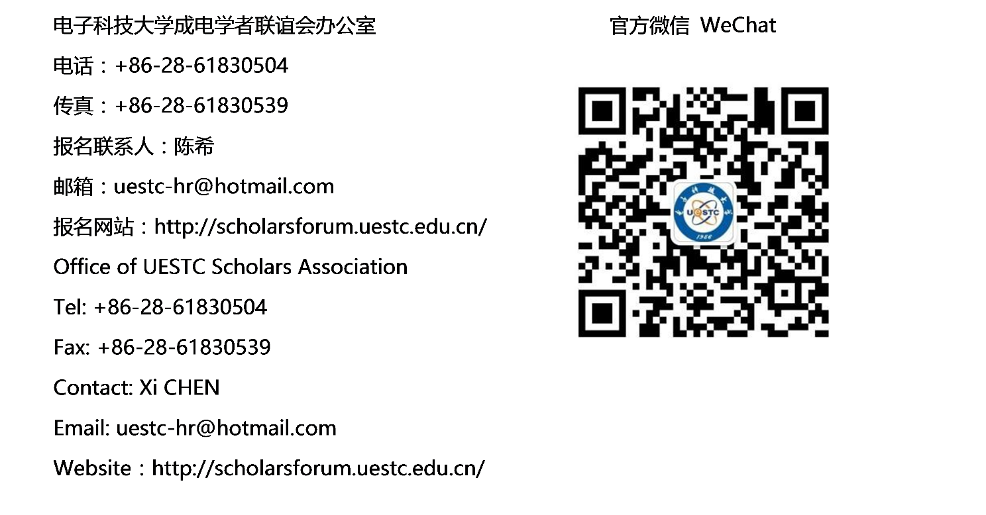
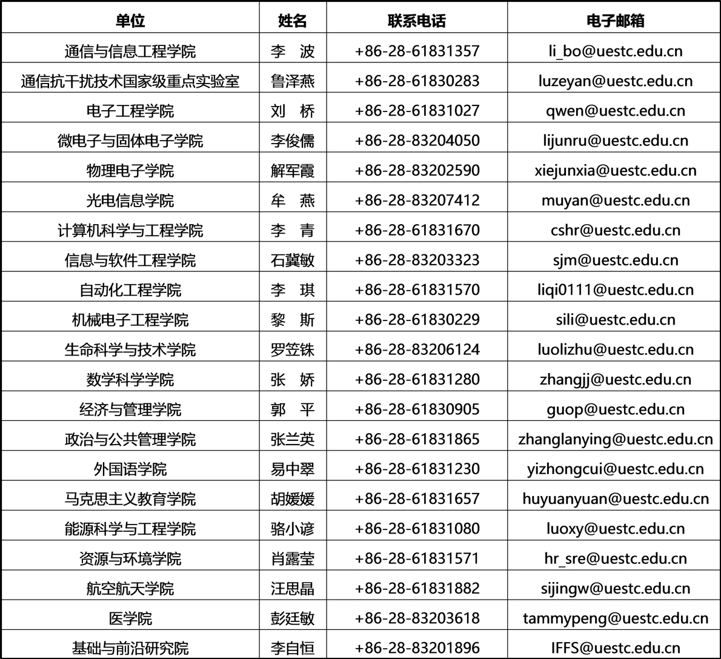
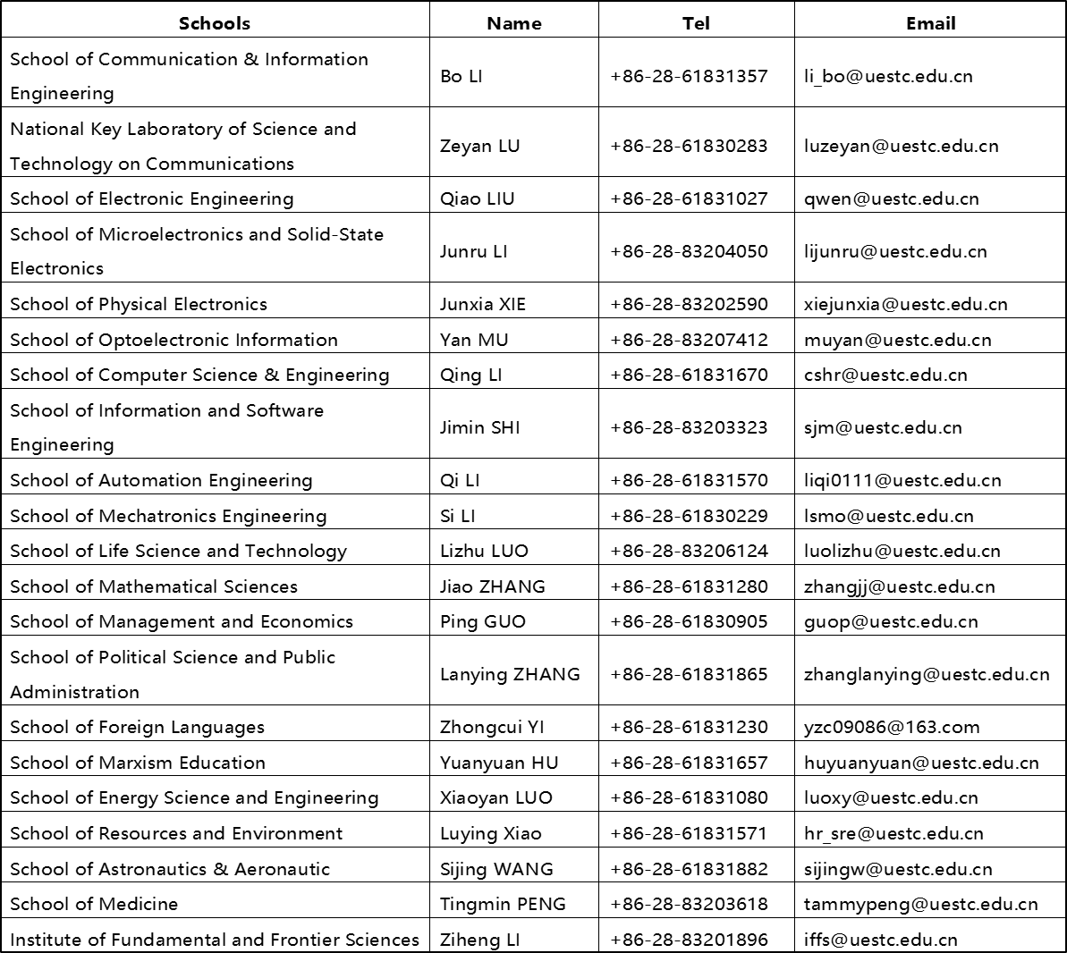

美丽成电欢迎您！
Thank you for concerning.
Welcome to UESTC.

